DASHBOARDS

1. AWS LOGIN SCREEN

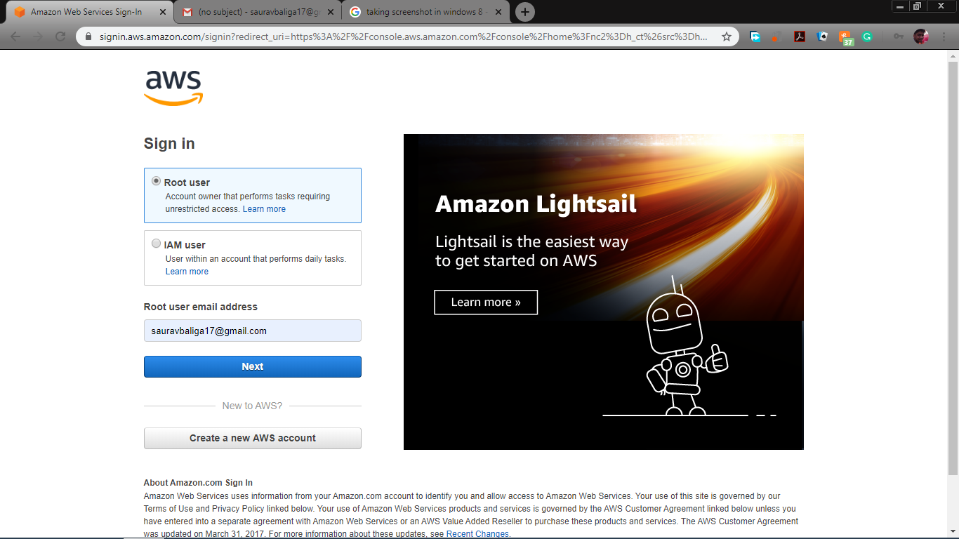

1. EC2 DASHBOARD

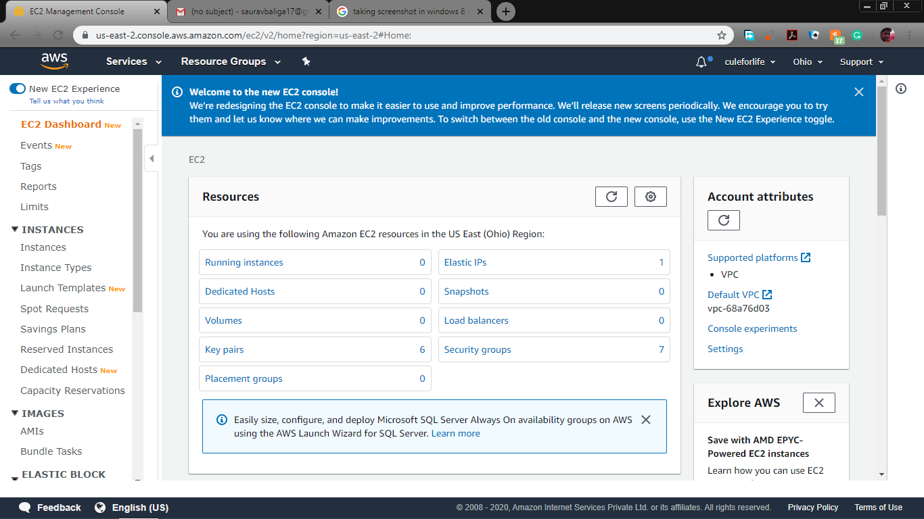

1. S3 DASHBOARD

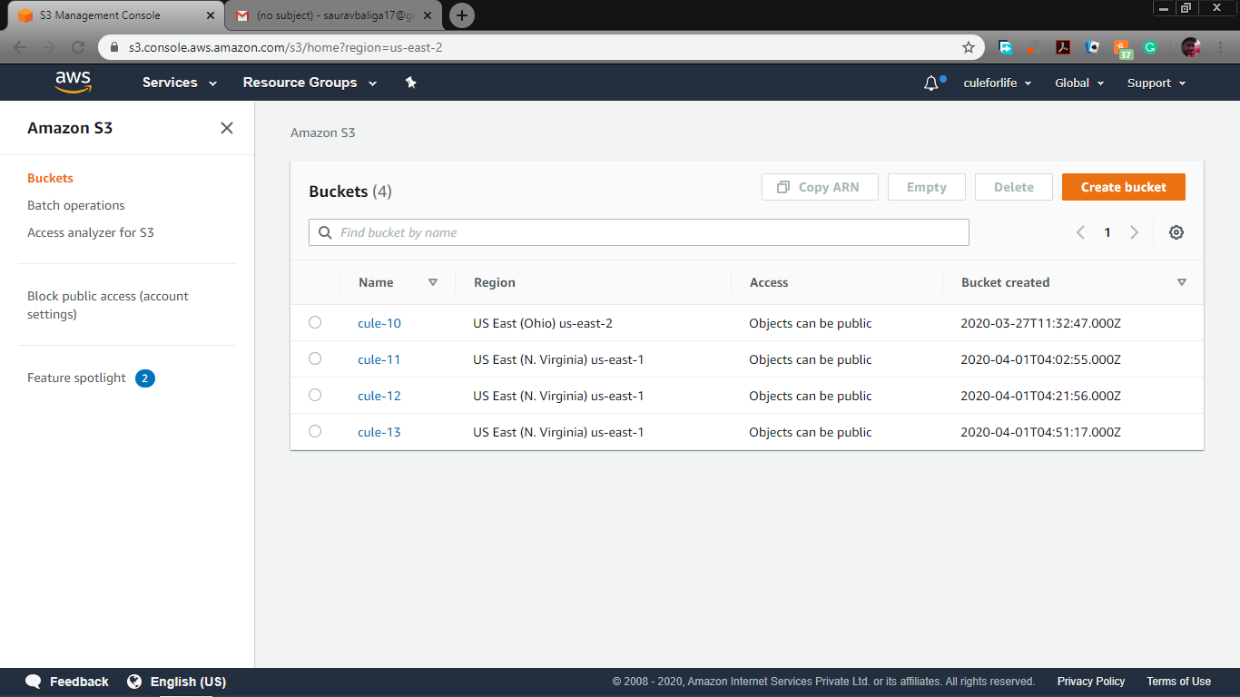

1. REKOGNITION DASHBOARD

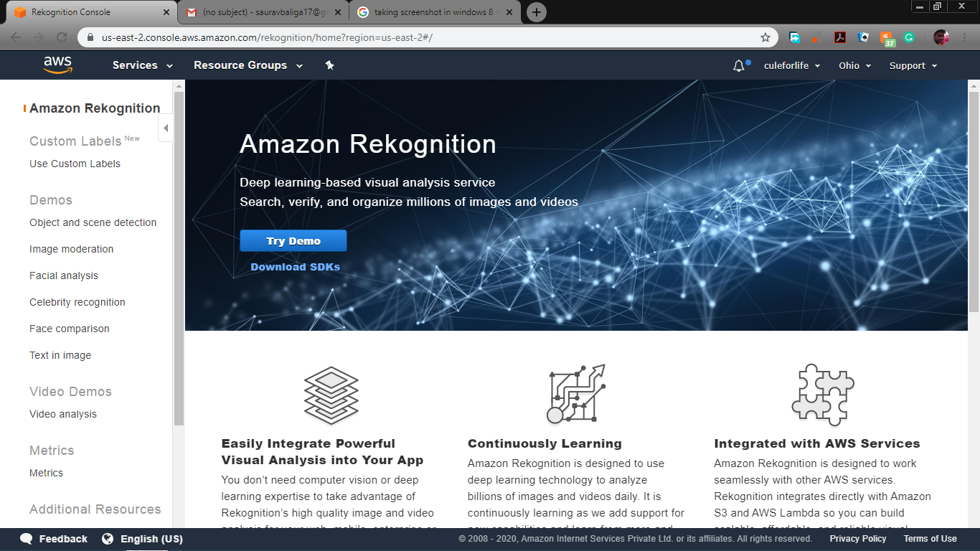

EC2

1. CHOOSING AN AMI

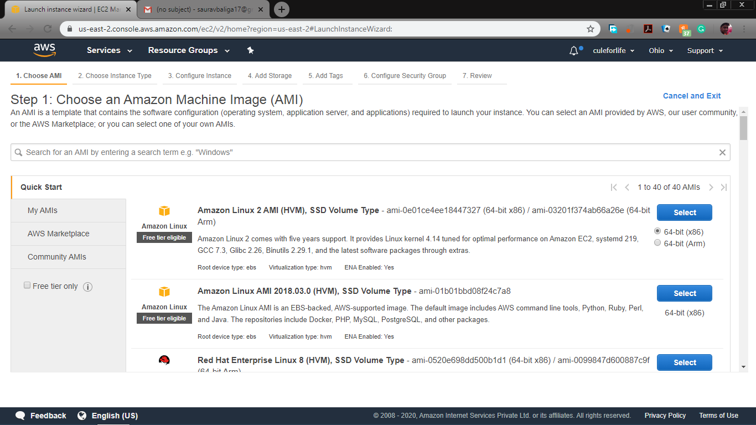

1. CHOOSING AN INSTANCE TYPE

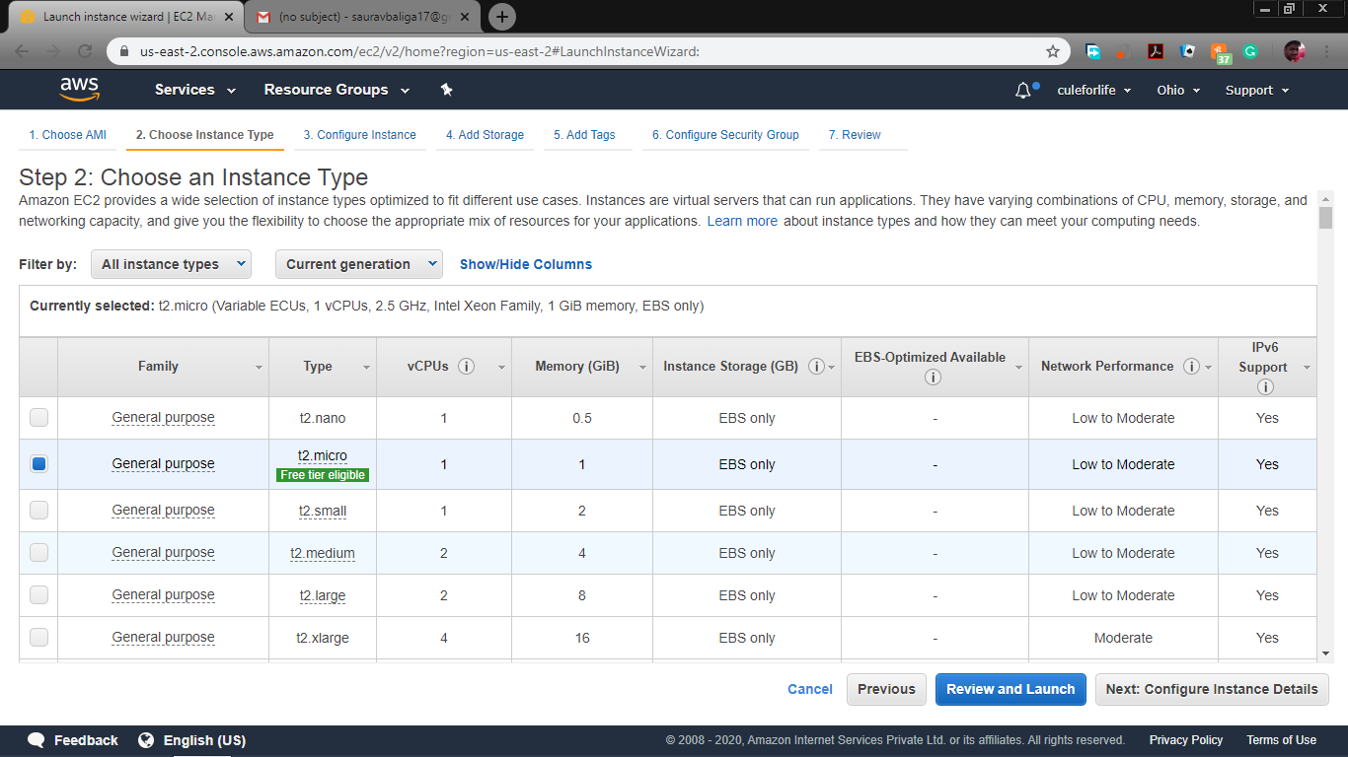

1. ADDING STORAGE

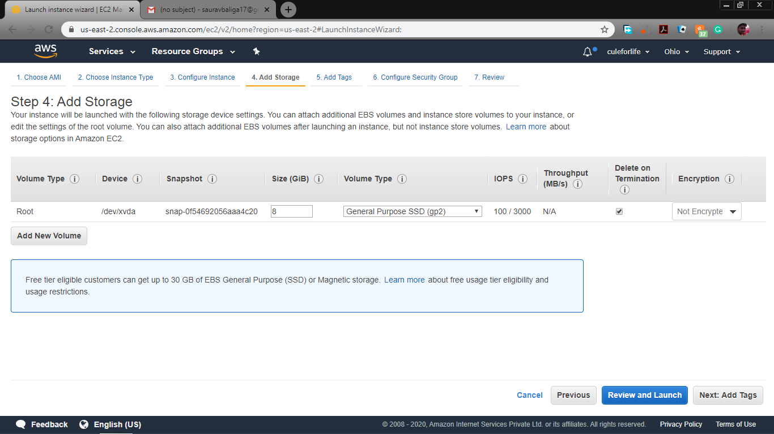

1. CONFIGURING SECURITY GROUP

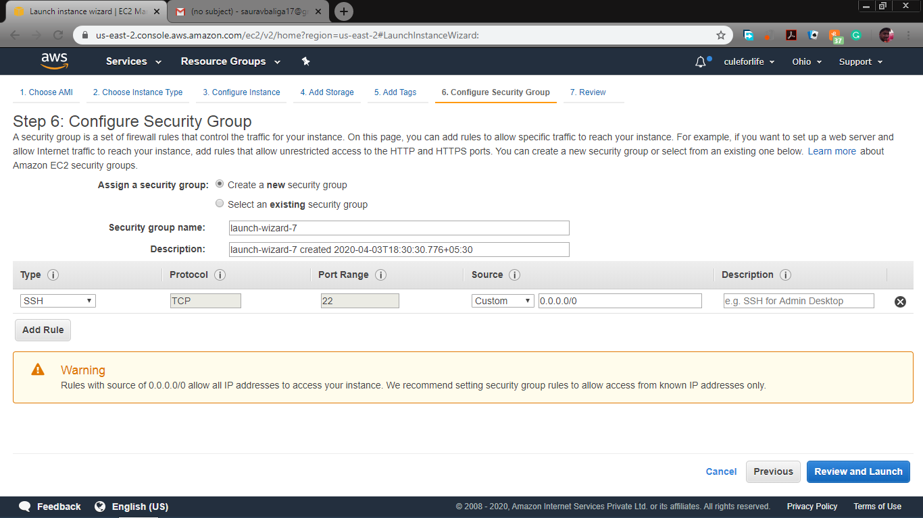

1. PuTTYgen CONVERSION FROM PEM TP PPK

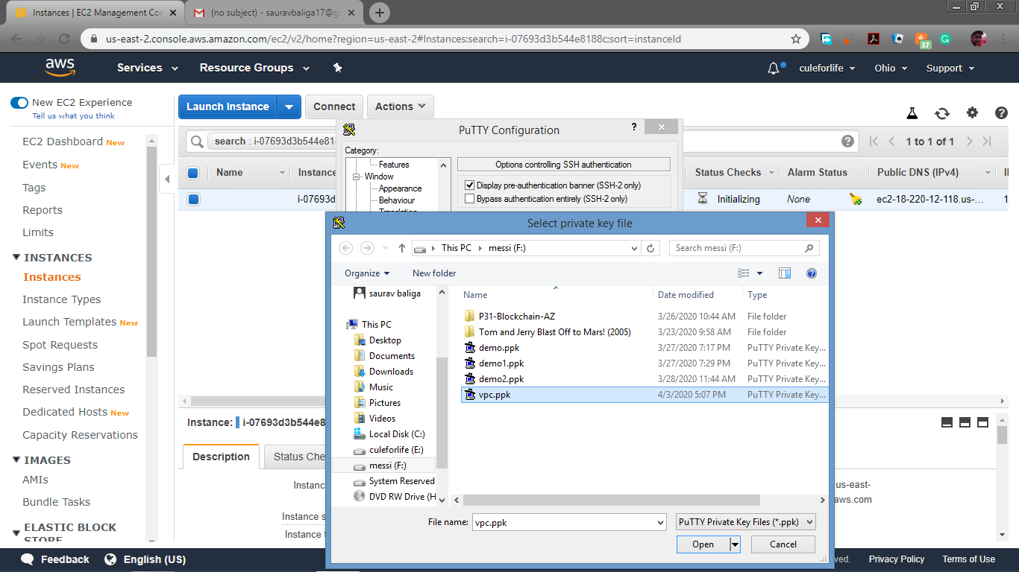

1. LOGGED IN EC2

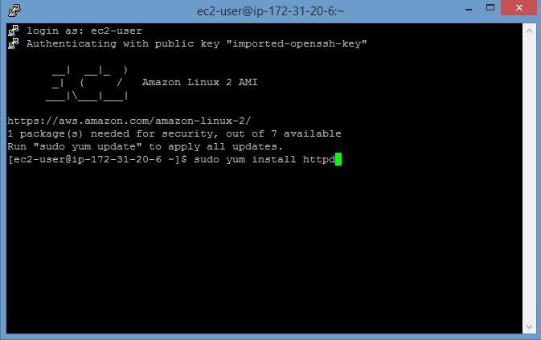

1. EC2 INSTANCE

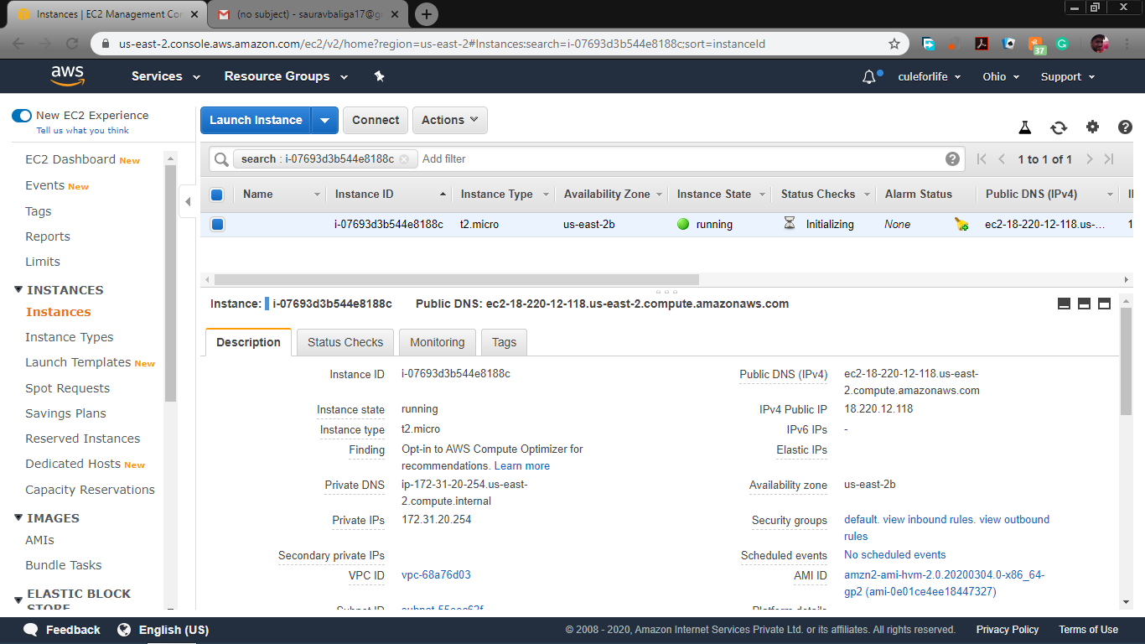

S3

1. CREATING A BUCKET

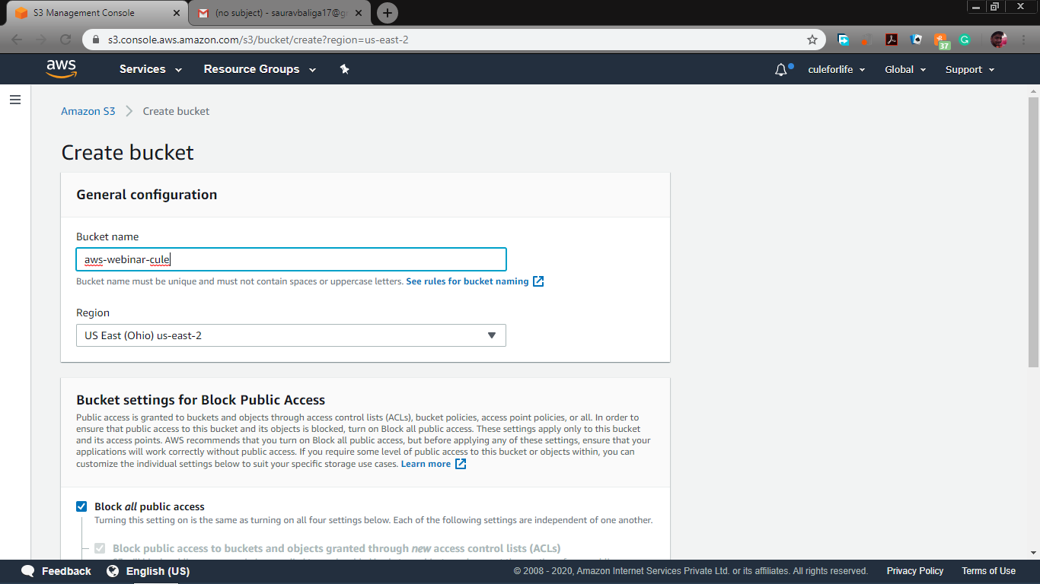

1. UPLOADING AN OBJECT



1. ENABLING STATIC WEBSITE

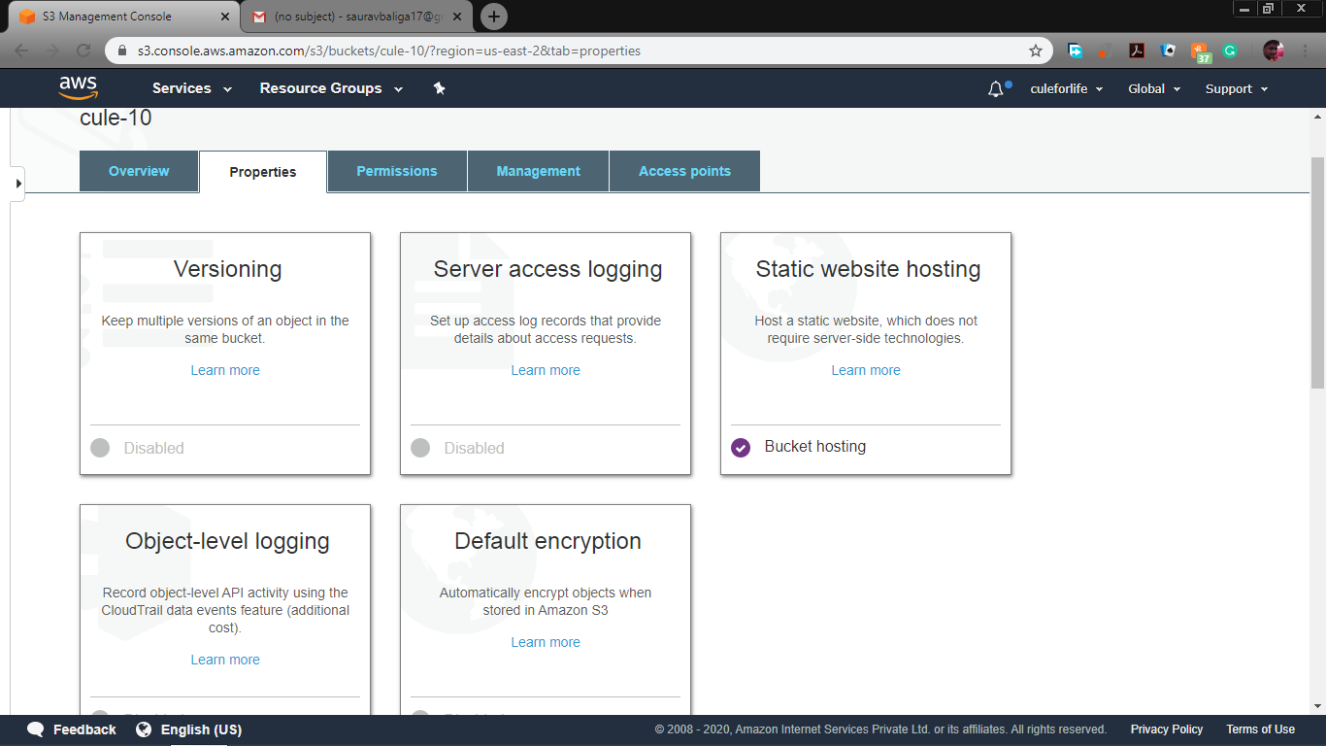

1. MAKING THE OBJECT PUBLIC

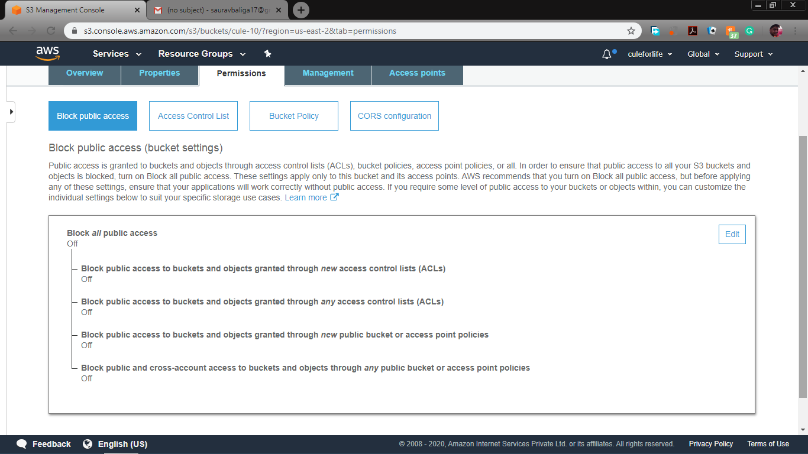

1. CHECKING S3 LINK

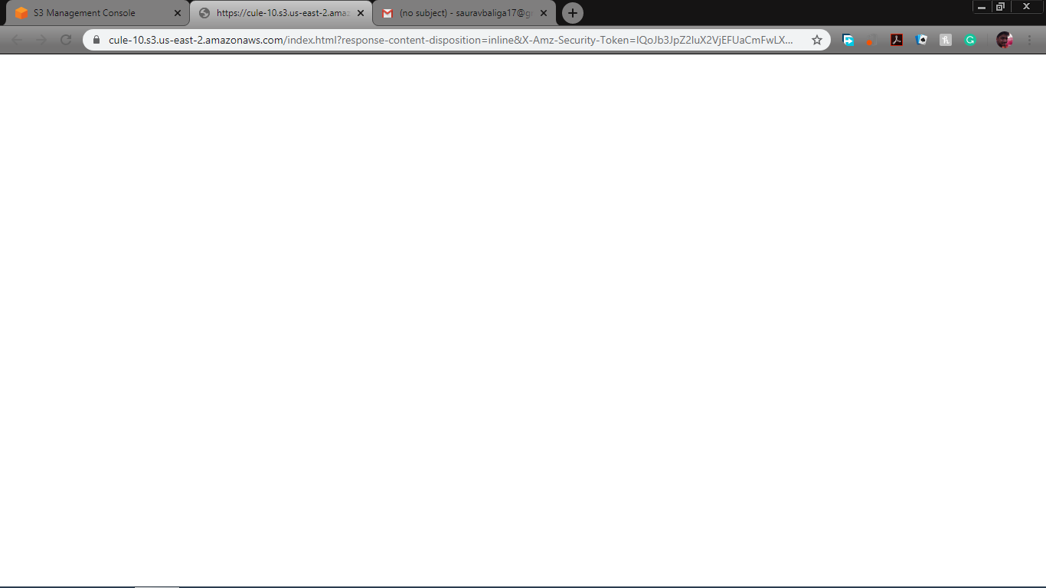

REKOGNITION

1. FACE DETECT

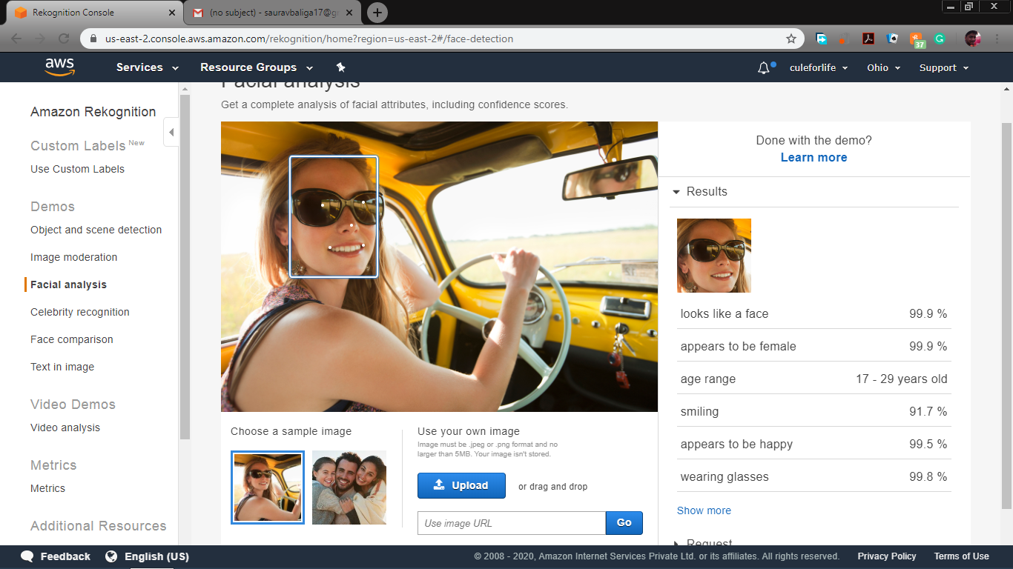

1. FACE COMPARISION

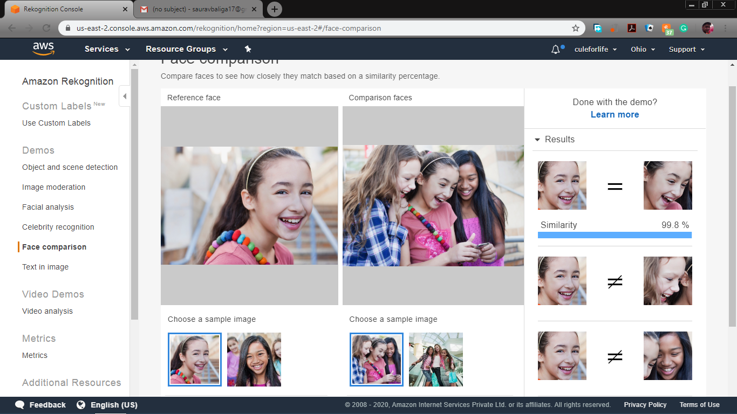

1. CELEBRITY RECOGNITION

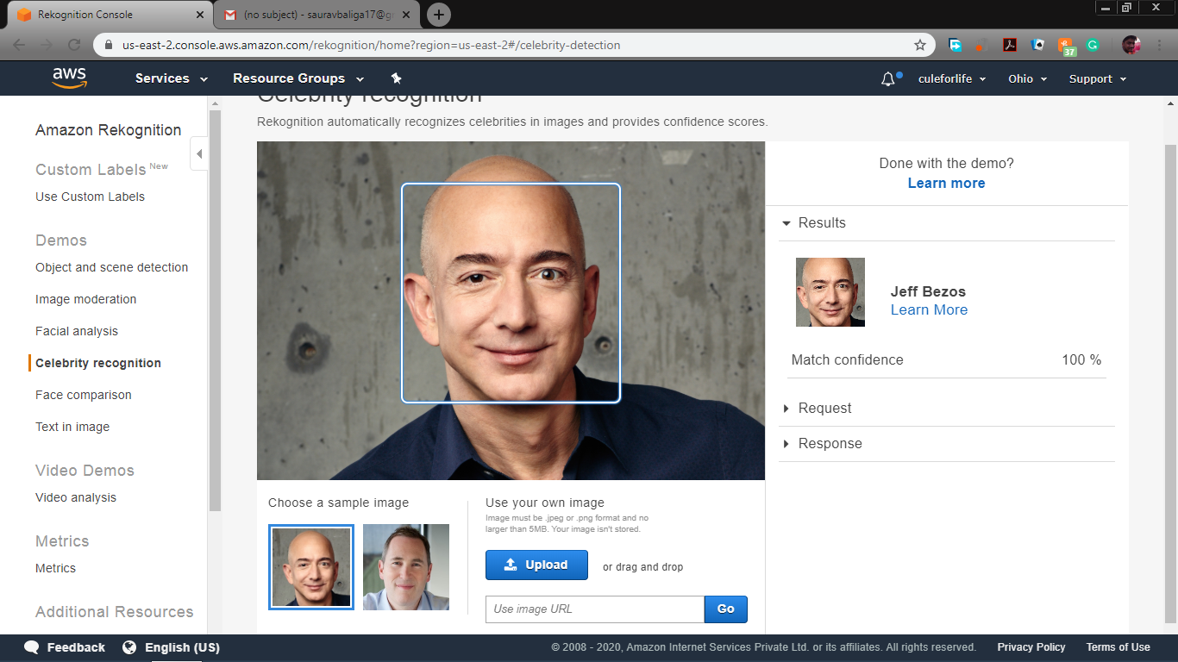

1. TEXT IN IMAGE

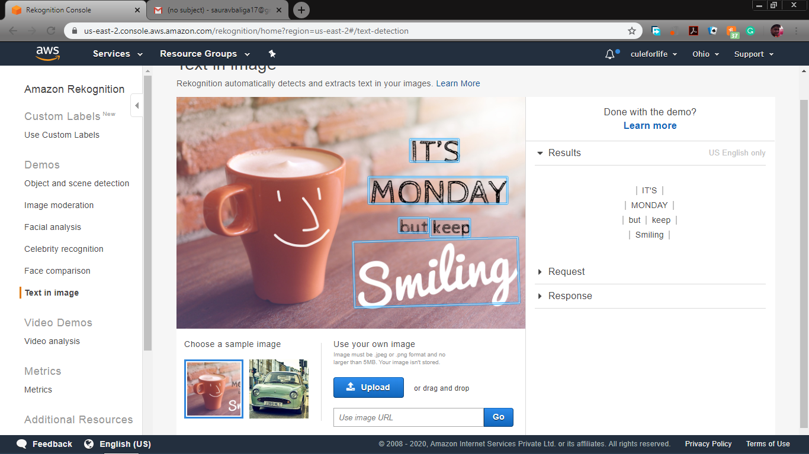

EC2 AND S3

1. INSTALLING AWS SDK

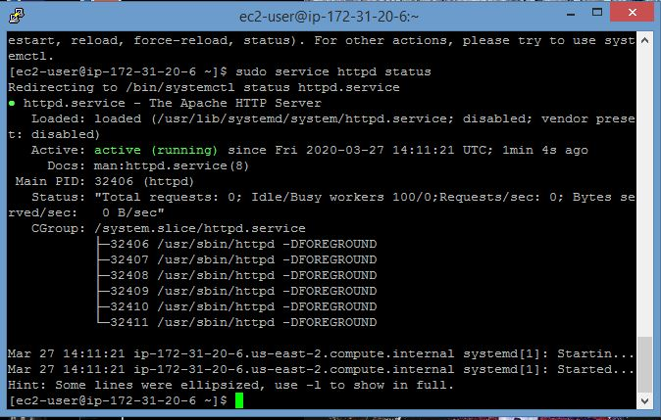

1. INSTALLING HTTP



1. UPLOAD SUCCESS

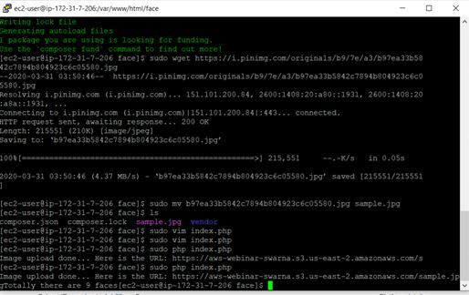

1. INDEX.PHP

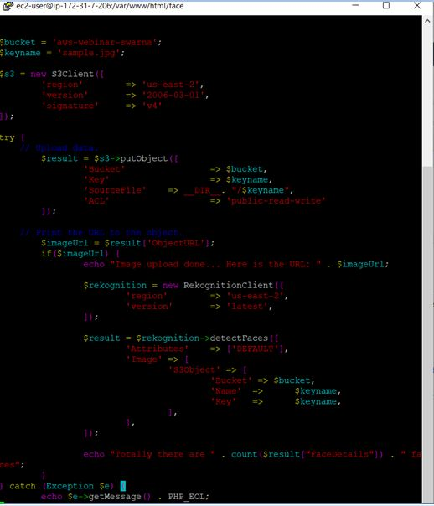

EC2 AND REKOGNITION

1. FACE DETECT SUCCESS SCREENSHOT

